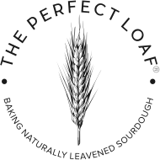

Baking with Steam in Your Home Oven

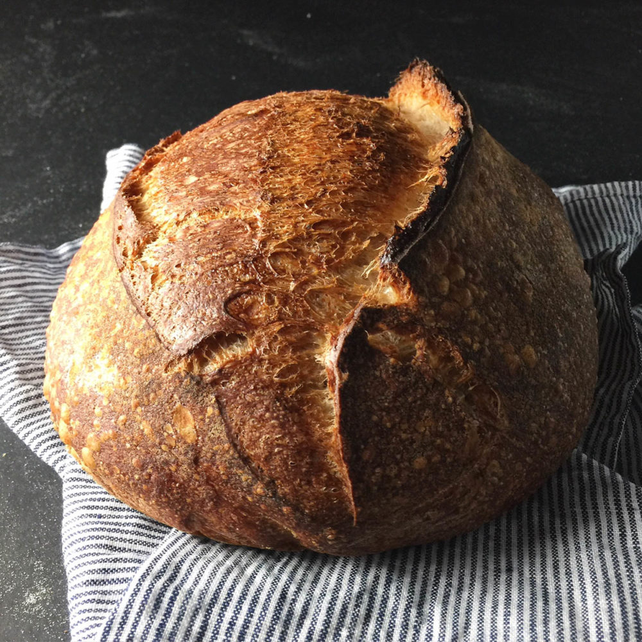
Steam burns hurt. Like really, really hurt. The small mark on my left forearm begs the question every day: Maurizio, was it really worth it?
But before we talk about my new baking badge of honor, let’s concentrate on overcoming the challenges of baking good bread at home. While many of these challenges present themselves early on in the two-day process (fermentation, flour selection, mixing, shaping, and so on), there is that key component at the end of this whole ordered procession: baking with steam in a high-temperature home oven.
For your bread to rise to its potential that outer, taut skin on your loaf needs to be able to expand and stretch before hardening off. Steam in the oven, and subsequently on the surface of your loaves, helps keep that skin pliable and stretchy during baking. If your dough dries and cooks too quickly on the exterior, the interior force generated by yeast/bacteria rapidly consuming food at high temperature will be dampened and never cause enough rise to attain that awesome open crumb, that fantastic fissure on top and that nice gringe that makes us grin.
So how can we get enough steam in the oven to keep those loaves rising? There are certainly methods abound and each person has a different approach, but arguably the most popular choice at the moment, and the one I started with, is baking bread in a Dutch oven. Chad Robertson of Tartine Bakery, and his excellent book Tartine Bread, was my first introduction to the method and it will make an excellent loaf with a wonderful crust. However, there comes a time when you might want to bake two (or more) loaves at a time, or perhaps your loaves are scaled larger than your Dutch oven can comfortably hold. An alternative to baking bread in a Dutch oven is bake directly on stones and generate sufficient steam in your home oven by some other clever means.
Professional baking ovens have steam on tap. Press a button and in goes a wave of steam over decks of newly loaded dough. I’ve never had the pleasure to work on one of these ovens (yet), but I’m sure there are other unknown challenges just the same. Now there are some home ovens that are “steam ovens” but the ones I’ve looked at are incredibly small. You might be able to fit two loaves but I could also fit two Dutch ovens in my current home oven; no advantage there. Some other alternatives can’t inject steam at a button press but they are sealed to trap steam and have a method for generating steam. These look very promising but are on the expensive side.
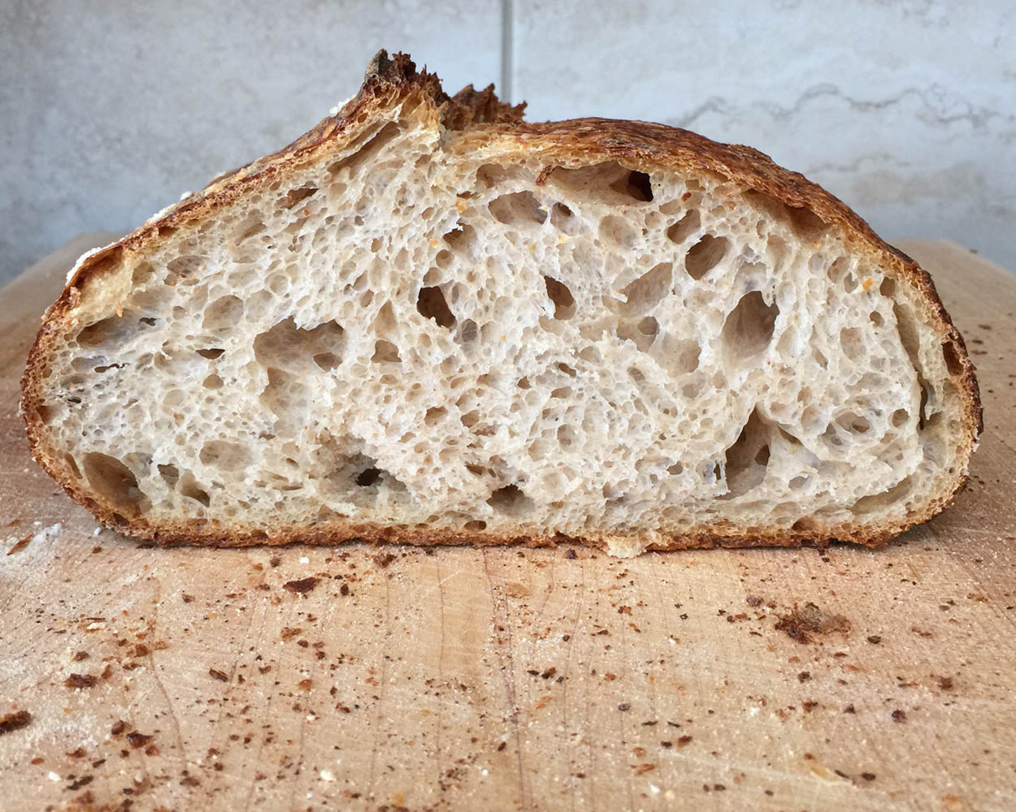
Since most of us bakers out there do not have one of these fancy ovens, we have to make do — read on to learn how baking with steam in your home oven can be a pretty easy process.

Tools for Steaming Home Oven
We first need to have the right set of tools for the job. Let’s go over a few more additions to our home-baking arsenal:

Lava Rocks
The first is a cast iron pan filled with lava rocks. Lava rocks are a primo choice because they get extremely hot, don’t breakdown easily and have tons of jagged sides and crevices for an incredible increase in surface area. What’s the big deal about surface area? As cooler water comes into contact with a blisteringly hot surface it instantly turns to steam. The more hot surface area you have, the more steam you generate. I found these lava rocks, which are specifically made for home BBQ grills, and they have turned out to be a perfect choice. They come in a fairly large bag and I am still on my first handful — I probably have lava rocks for life.

Cast Iron Grill Pan
The second component is the cast iron pan I use to hold the lava rocks. This Lodge Cast Iron Grill Pan is great for a few reasons: Lodge makes awesome iron products (they make the Dutch oven I’ve been baking with for years), cast iron can get super hot & retains heat very well, and the grill lines on the bottom yet again increase surface area.

Rectangular Baking Pan
The last component is an old rectangular baking pan with a bunch of small dish towels rolled up inside. I simply use an old pan from around the kitchen and roll up 3 small towels placed in the center. The more towels you add, the more steam you’ll generate. I use cheap, clean towels as these will eventually get scorched and will need replacing.
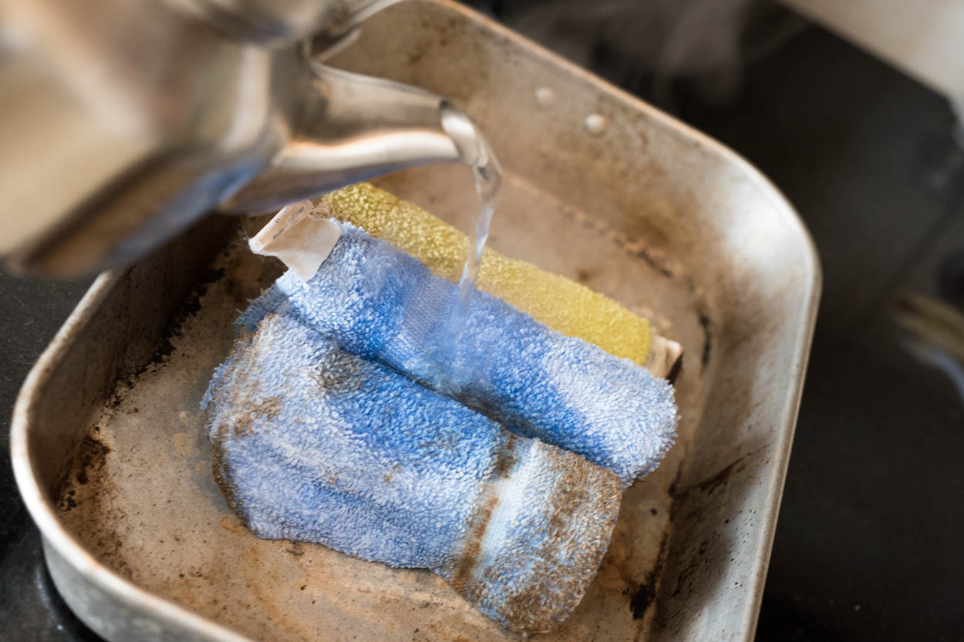
Ten to twenty minutes before you plan to start baking, you will boil some water and pour it over the towels in the rectangular pan so they are fully drenched and steaming. You will then place this pan with towels back inside your oven. This pan will saturate the interior with steam before you even splash water on the lava rocks, and will continue to do so well into the bake.

Optional Hand Spritzer
The final item is optional. A stainless steel hand spritzer I use to spray in a bit more steam just before closing the oven door. I like to have the option to spray in a bit more steam if I feel it warranted. Additionally, you could use this after 5-10 minutes into the bake to quickly saturate the inside of the oven one more time. Some bakers, like Jeffrey Hamelman in Bread, recommend this second round of steaming in a home oven.
Not many new tools needed, really, and if you think about it over the long run you will probably save money as now we can bake 2-4 loaves at a time — no more wasting all that space in the nice and hot oven. Now that we have the tool requirements squared away, how do we actually do this thing?

Baking Steam Method
The following does take a bit of practice. First, make sure you get all your tools ready and within reach, this is a rather hectic process and you want to do it almost without thought — muscle memory. The longer your oven door is open the more heat will escape. Your thick baking stones will help offset some of the loss, but you still want to act quick.
Below is a quick visual showing where I have my pans, where the loaded dough goes and where my baking stones are. I feel like sometimes you just need to see things how I see them just before loading bread.

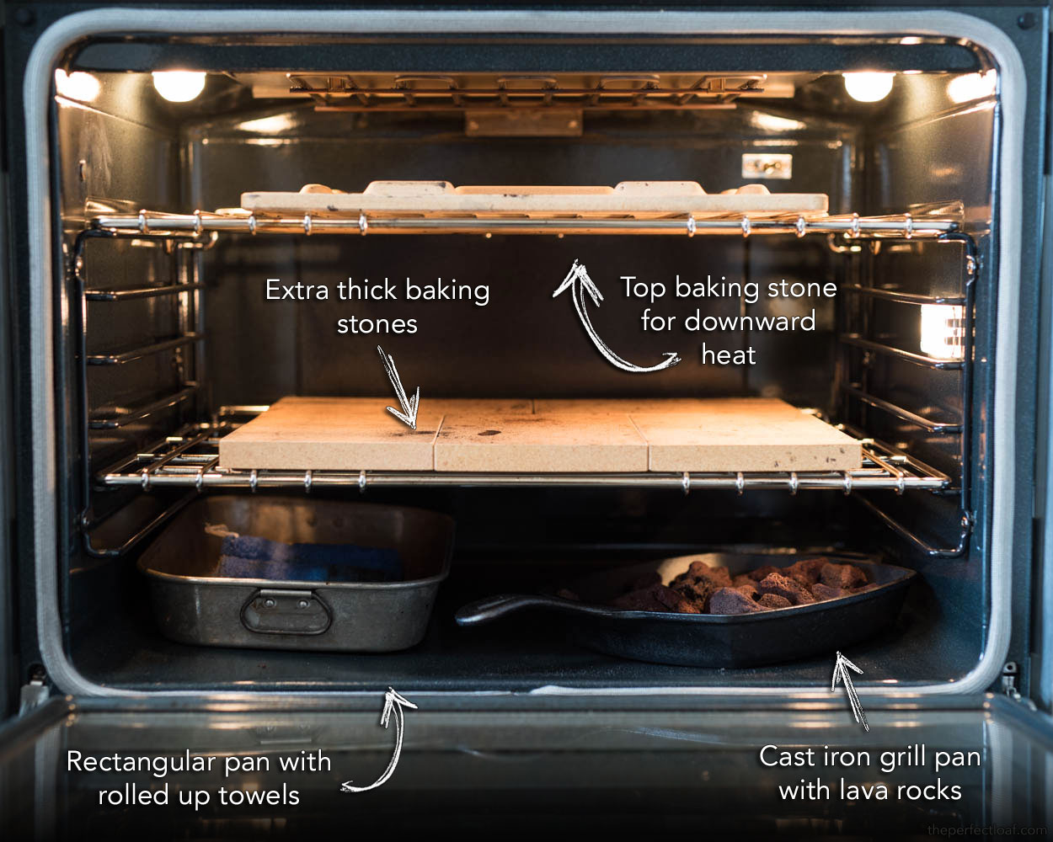

Now that we have a list of what things we need, where things will be placed and why, let’s get to the actual method (with animated version below!).

Method:
- An hour before baking, turn on your oven (preheat)
- 10-20 minutes before loading your bread boil water, pour over the towels in your rectangular baking pan, fully saturate them, and place in the back corner of your oven
- 10-20 minutes after loading the pan, place each mass of dough on a separate piece of parchment paper
- Place dough, and sheets underneath, on a pizza peel
- Score dough
- Open oven and slide-in dough (with parchment) onto baking stones
- Quickly lay towel down on oven door glass (optional, you can see me doing this below)
- Carefully toss 1 cup water into your cast iron pan with lava rocks
- Quickly spray loaves a bit with hand spritzer (optional)
- Close oven door and watch your dough rise
- 20 minutes later remove both rectangular and cast iron pans (careful these are extremely hot) to stop steaming
- Bake as usual until done
Whew, that’s it! Here is the whole process (minus the preheat and drenching of towels) in one trendy baking-with-steam GIF:
Why do we use two sheets of parchment paper for our dough? When you use two sheets you can adjust the space between the loaves as they bake, if necessary. One of the worst things to happen is when the dough expands and joins with another loaf, this reduces the overall rise on both loaves. If you notice they start to get a bit close, quickly slide them apart.
After 20 minutes of baking we remove the cast iron pan and the rectangular baking pan so no more steam is generated, which allows your loaves to crisp up and harden off.

Another Approach
If you’re curious for yet another way, Thom Leonard has a method using a roasting pan, or oven-safe bowl, inverted over your baking loaves to trap steam as the water is cooking out of your dough (similar to the Dutch oven method). You can see Thom’s steaming method right here. I tried this method on a few occasions and sadly had issue with my roasting pan; my bread rose so high it lifted the pan off the bottom, smashing the top of my loaf AND releasing steam far too early. I don’t have a bowl/pan large enough to fit my rising dough.

Conclusion
I like this method for baking with steam in my home oven because it allows me to cook two large loaves of bread at a time. Actually, I plan to bake 4 loaves at a time and this will allow me to do that with no problem. Baking with a Dutch oven (or combo cooker) works extremely well, and I might still use that method if doing only a single loaf or a highly hydrated one (the pan will help keep the dough together), but I find myself using this new method more and more. The results have come out smashingly.

