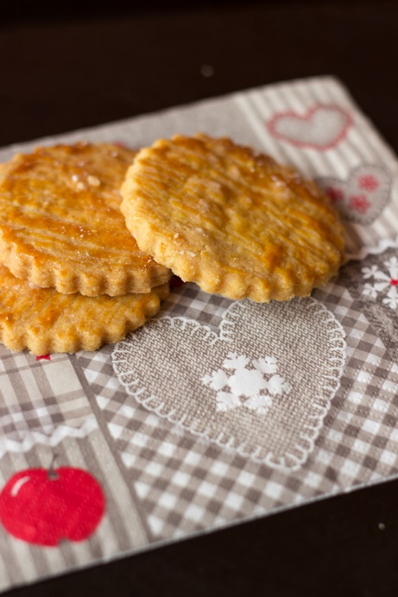
Breton Butter Biscuits
Prep time: 1 hour 30 mins
Cook time: 30 mins
Total time: 2 hours
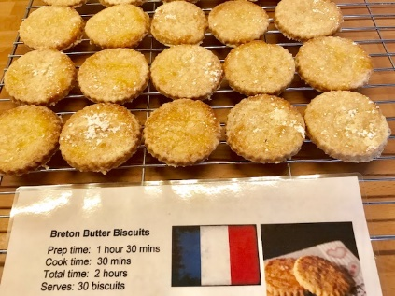
Serves: 30 biscuits

Ingredients
- 320 gr. of flour
- 120 gr. of sugar
- 12 gr. of vanilla or golden sugar
- 2 egg yolks
- 200 gr of melted salted butter
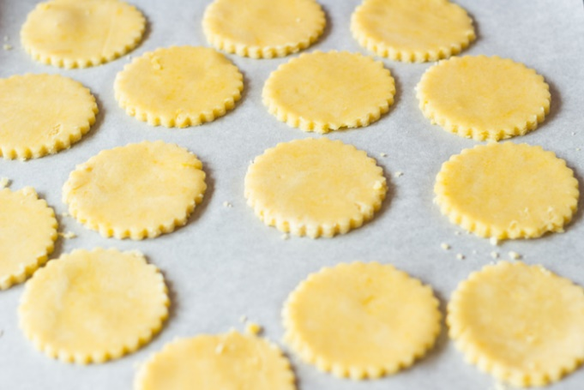
- 1 whole lemon zest
- 1 egg yolk
- 1 teaspoon of water
- 1 heaped tablespoon of icing sugar
Instructions
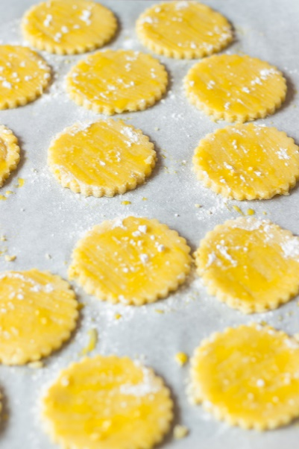
- Mix flour, sugar and vanilla sugar. Make a well in the centre. Add 2 egg yolks, melted butter and lemon zest. Knead and form a ball. Cover with kitchen film and leave to rest for 1 hour.
- Preheat oven to 150 °C (300°F). Put greaseproof paper on baking tray and reserve.
- Roll dough in between to baking sheets to the appropriate thickness (3 mm). Cut out circles of dough (diameter 7 cm) using cutter and put on baking tray.
- Mix 1 egg yolk with 1 teaspoon of water. Apply on biscuit using a cooking brush. Sprinkle icing sugar and bake for 20-30 minutes

