Doves Farm Flour Guide
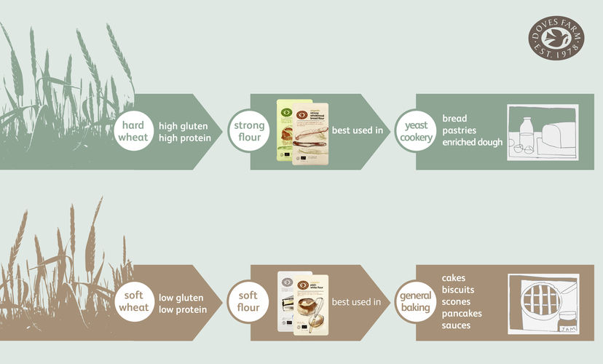

Types of Flour
What differentiates types of flour and how can you choose the one that's best for your bake? With many types of flour available, and often with varying names, it can be difficult to know. From your wholemeal to your white, and strong to plain, here’s our essential guide to help you get to know your flours.
Choosing the right grain
Before we even begin to mill grain into flour, we must choose the right grain for the job, be it for breadmaking, cakemaking or anything in between. So, what distinguishes one grain from another? It’s all down to the protein quality and its ability to form gluten, a sticky protein present in wheat, rye and barley which enables the dough to become elastic. There are two types of gluten present in the endosperm of a wheat berry: gliadin and glutenin. When flour is mixed with water and yeast, these proteins form gluten, which expands and becomes elastic, forming a network of fine membranes which trap small bubbles of air and enable the dough to rise. This is ideal for bread baking but for cakes and pastry making a less elastic dough will work best.
Soft wheat vs hard wheat
Depending on the protein content of the wheat grain, it is categorised into what farmers and millers refer to as hard wheat or soft wheat.
Hard wheat has a high protein content and if it also has good quality gluten, it can develop a strong and elastic dough, making it the best type of wheat to produce bread flour.
Soft wheat has a lower gluten content and is used to make plain flour and self-raising flour, making it ideal for making cakes, biscuits and pastries.
With soft wheat varieties, we make:
Plain Flour
Plain flour is milled from soft wheat varieties and has low gluten and protein content which makes it suitable for biscuits and pastries where a crumbly texture is needed.
Also known as: all-purpose flour, cake flour, pastry flour and soft wheat flour.
Best for: biscuits, scones, crumbles, pancakes, shortcrust pastry and sauces.
Self-Raising Flour
Self-raising flour is milled from a blend of hard and soft wheats. Self-raising flour already contains raising agents which gives a nice rise to baked goods, so you do not need to add this into your mixture. You can also make your own self raising flour by adding 2 level teaspoons of baking powder to every 100g of plain flour. We suggest sieving both of these ingredients and stirring until they are well mixed.
Best for: cakes such as sponges, and scones, some biscuits and suet pastry.

And with hard wheat varieties we make:
Strong Flour
Strong flour, also commonly known as strong bread flour, is made from hard wheat varieties. It contains more gluten than other types of flour which gives it its elasticity and enables the dough to rise with a good structure. Rather than fortifying the flour by adding refined gluten, at Doves Farm we blend our home-grown varieties of wheat with imported hard wheat to give the best results when baking bread.
Also known as: bread flour.
Best for: yeast cookery and enriched doughs. Strong White flour is also used for choux pastry and filo pastry.
Pasta flour
Made from very hard wheat varieties, pasta flour is ground to a fineness which makes it perfect for making pasta from scratch. This flour gives the dough a firm yet silky texture and makes it easy to roll to the thinness needed for great pasta.
Best for: you guessed it, pasta!
Wholemeal or White?
Plain, self raising and strong bread flour can be either wholemeal or white. We determine whether a flour is wholemeal or white by how much of the germ, the bran and the endosperm is removed during the sieving process. Discover more below.
Wholemeal or whole-wheat flour is made from milling the ‘whole wheat’, meaning that all three parts of the wheat are ground to create the flour. As it is milled from the whole grain, it retains its natural nutrients, the most of which are found in the germ and the bran, making it higher in fibre and nuttier in taste than white flour.
White flour contains only the endosperm and is made by sieving out the coarser wheat particles, which includes the bran and wheat germ. The fineness of white flour makes it ideal for more delicate bakes, such as fine patisserie and light sponges.
Stoneground Flour
We mill many of our organic ancient grain flours, as well as many of our other organic flours, the old-fashioned way using a stone mill, a traditional technique that has remained largely unchanged from ancient times. Stoneground flour is, very simply, when grain is ground between two mill stones. Stoneground flours tend to have a richer flavour and texture and are widely used by artisan bakers, who like to work with baking ingredients and techniques of our heritage.
Organic Flour
Organic flour is milled from grain that is grown using organic farming methods. Growing grain organically means that the farmer has to meet a strict set of standards that involve high levels of environmental welfare, and no use of artificial fertilisers or pesticides. In addition the farmer, miller and baker have to undergo annual organic inspection and certification.
Ancient Grain Flour
At Doves Farm, we also produce many flours from ancient grains such as Einkorn, Emmer, Spelt, KAMUT® Khorasan and Rye. These flours have distinctive characteristics and flavours which lend themselves to a whole variety of bakes. If you are keen to experiment with different flavours, crumb structures and experience the baking traditions of our past, then try baking with our range of ancient grain flours.
Gluten Free Flour
We have been milling naturally gluten free flours since we were founded, as an alternative to wheat-containing flours for those who follow a gluten free lifestyle. Sold under the FREEE brand these are produced in a dedicated mill from natural wholegrains, such as brown rice and quinoa, our blends mean that you don’t have to mix your own..

